Phong Model/Specular Reflection

When we look at an illuminated shiny surface, such as polished metal, an apple etc we see a highlight or bright spot , at certain viewing direction this phenomenon is called “specular reflection” and is the result of total or near total reflection of the incident light in a concentrated region around the “specular reflection angle”.

This angle is equal to the angle of incidence.

N – unit normal surface vector
R – unit vector in the direction
of ideal specular reflection
L – unit vector directed towards
point light source
V – unit vector pointing to viewer
from the surface position
Ø – viewing angle relative to
specular reflection direction R

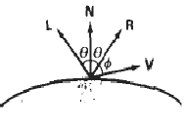

For ideal reflector (perfect mirror) incident light is reflected only in the specular reflection direction i.e. V and R coincide (Ø = 0 ).

Shiny surfaces have narrow Ø and dull surfaces have wider Ø

An empirical model for calculating specular reflection range was developed by Phong Bui Tuong called “Phong specular reflection” model and it sets the intensity of specular reflection directly proportional to cosnsØ Ø → 0 to 90
Specular reflection parameter n_{s} is determined by type of surface

Very shiny surface has large n_{s} value
Very dull surface has smaller n_{s} value (down to 1)

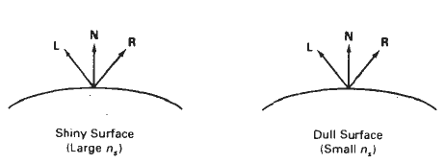

Rough surface, e.g. chalk has n_{s} = 1

Intensity of specular reflection depends on material properties of surface, 0,other factors such as polarization , color of incident light.

For monochromatic specular reflections intensity variations can be approximated by SR coefficient W(Ө)

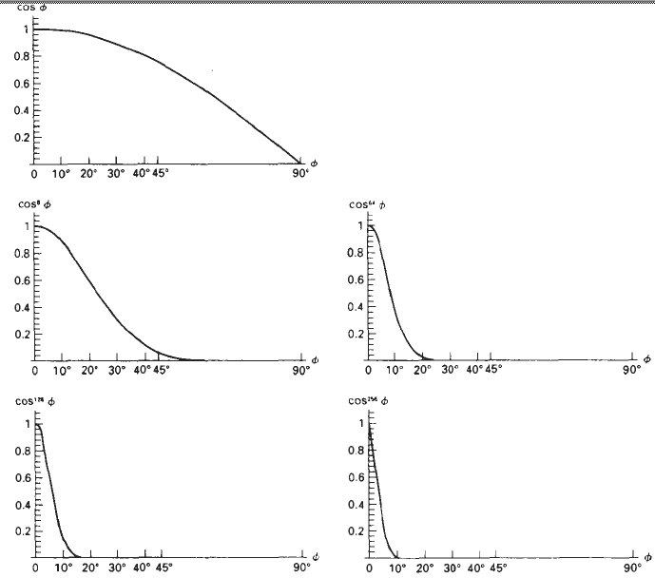

W(Ө) tends to increase as Ө increases, at Ө = 90 W(Ө) = 1 and all incident light is reflected.

Fresnal’s law of reflection describes specular reflection intensity with Ө and suing W(Ө), Phong specular reflection model as
I_{spec} = W(Ө) I_{L} Cosns Ø
where I_{L} is intensity of light source
Ø is viewing angle relative to the specular reflection direction R.

So transparent materials like glass exhibit specular reflection as 0 approaches 90. At 0 = 0 about 4 percent of the incident light on a glass surface is reflected.

Now also I_{spec} = W(Ø ) I_{L} ( V . R ) as V . R = Cosns Ø

R can be calculated in term of N and L

R + L = (2N . l)N or R = (2N . l)N – L

Simplified Phong model is obtained by halfway vector H between L and V to calculate the range of SRs

Replacing V . R in equation with N . H → Cos Ø replaced by Cos α Half way vector H
H = L+V
|L + V|
If both viewer and light source are sufficiently far from surface both V and L are constant over the surfaces. Hence H is constant.

For non Planar surfaces N.H requires less computation than V.R

If V is coplanar with l and R(also N) then α = Ø / 2

If V,L,N are non coplanar then α > Ø / 2

Combined diffuse and specular reflections with multiple light sources

For single point light source
I = I_{diffuse} + I_{spec} = K_{a} I_{a} + K_{d} I_{L} ( N . L ) + K_{s} I_{L} ( N . H )n_{s}

For multiple light sources

n
I = K_{a} I_{a} + _{Σ} I_{Li} [ ( K_{d} ( N . L_{i} ) + K_{s} ( N . H_{i} ) ns ]
i =1

